- So far, alternative indicators show no noticeable impact of the Middle East conflict on UK activity. But we think this will begin to change over the coming weeks, with fuel demand likely to contract and discretionary spending set to be squeezed. Households have some scope to mitigate the impact via lower saving, but we expect consumer spending to be flat this year.
- Bank of England Governor Andrew Bailey was unusually forthright in his comments on monetary policy this week. He highlighted the need to minimise the damage to activity and jobs, and suggested markets were "getting ahead of themselves" in pricing a series of rate hikes. We're still comfortable with our call that Bank Rate will remain at 3.75% for a prolonged period.
It's been a little over a month since the US/Israel-Iran conflict began and evidence on the economic impact remains scarce. Official economic data published over the past week still relates to the pre-conflict period. So business surveys and alternative data sources provide our only information on the impact so far.
In January, we published a note outlining our approach to alternative data sources. Much of this data is available on a weekly or even daily basis. It can be very volatile at such a high frequency, so we normally aggregate to a monthly frequency. However, in the current context, there's some value in looking at the weekly data to see if there's any sign of behavioural change.
Most indicators are available for at least the first three weeks of March, and so far, there's little evidence of an impact on activity (Table 1). Data from Revolut suggests debit card spending remains solid. There's been no clear change in the mobility indicators, with car journeys and the quantity of fuel purchased holding up despite the sharp increase in fuel prices over the past four weeks.
Table 1: Alternative indicators show little evidence of an impact from the Middle East conflict so far
Sources: Office for National Statistics, Department for Transport, Insolvency Service, Indeed, Revolut, EUROCONTROL, Elexon

But the experience of 2022 suggests this picture will change over the coming weeks. The RAC reports that diesel prices are now more than 40 pence per litre (29%) higher than the end-February level, with unleaded petrol up 21 pence (16%). If pump prices continue to rise, we're likely to see fuel demand contract and discretionary spending begin to be squeezed.
Furthermore, this week's S&P Global manufacturing survey suggested that broader goods price pressures are building. In March, input costs rose at their fastest pace since October 2022 and, despite some margin compression, output price inflation rose to a 10-month high.
The scale of the increase in inflation and the extent of the squeeze on household spending power will be heavily influenced by how oil and gas prices respond to the evolving conflict. In 2022-2023, consumers mitigated the impact of falling real incomes by saving less, and there's scope for households to run this playbook again now.
This week's national accounts release reported that the household saving ratio spiked up again in Q4, driven by non-pension saving, which has been particularly high of late (Chart 1). Outside of the pandemic, Q4's contribution of non-pension saving to the household saving ratio has only been bettered once (in Q4 2024) since the early 1990s. This suggests that a decent chunk of the high level of saving in recent years has been discretionary, implying room for the household sector to lean against the squeeze on their spending power. Still, even with this support, we think consumer spending is likely to be relatively flat this year.
Chart 1: Non-pension saving has been running at very high levels in recent quarters
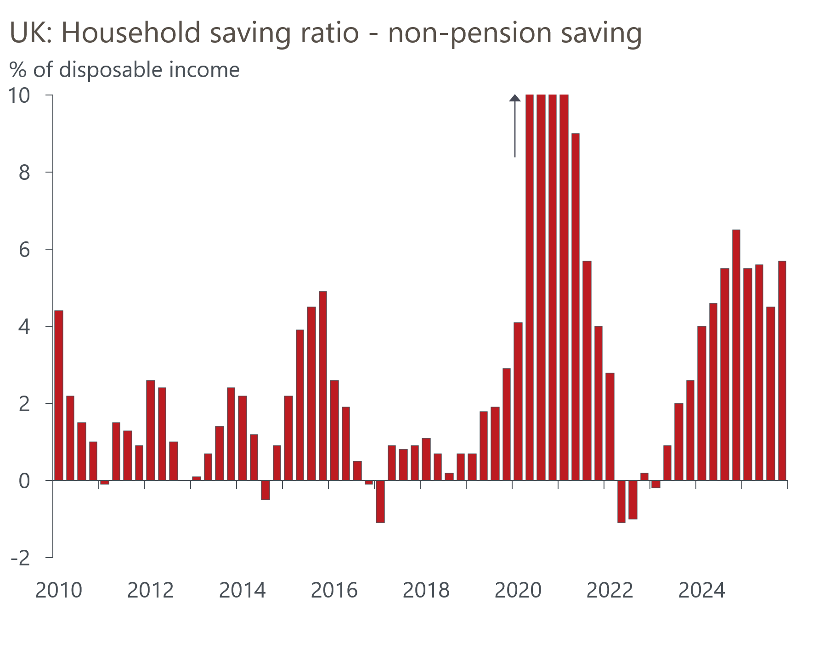
Source: ONS
Comments from Bank of England Governor Andrew Bailey this week suggested that he's alert to the impact of the conflict on activity. In an interview with Reuters, Bailey said "Of course, we have to deal with the shocks that come our way. But our remit is very clear on this that ... we have to do so in a way that ... causes the least damage in terms of activity in the economy and in terms of jobs."
At the same time, the Governor was unusually critical of markets' expectations for interest rates. Bailey said "(The market)'s still pricing us to raise rates. I would still say that is a judgment markets have to make but I think they're getting ahead of themselves." While it's true that the Governor is only one of nine voters, he's usually a good barometer for the views of most internal committee members. He's also been the swing voter in many of the meetings over the past year. In this context, we remain comfortable with our baseline forecast that Bank Rate will remain at 3.75% for a lengthy period.

The week ahead
Next week's only releases are the remaining S&P Global surveys for March. The flash survey reported chunky falls in the services and composite PMIs. The flash survey closed on March 20, and the experience of the manufacturing survey suggests that the extra time to digest the implications of the US/Israel-Iran war will have caused sentiment to deteriorate further. So we look for the final outturns for the services and composite PMIs to come in below the flash results.
Table 2: Week ahead calendar
Date | Events | Period | Measure | Unit | Previous | Forecast
Apr 7 | S&P Global services | Mar | PMI | % bal | 51.2 | 50.7
Apr 7 | S&P Global composite | Mar | PMI | % bal | 51.0 | 50.5
Apr 8 | S&P Global construction | Mar | PMI | % bal | 44.5 | 43.0
Source: Oxford Economics

Key forecasts
Table 3: UK forecast overview
(Annual percentage changes unless specified)
 | 2023 | 2024 | 2025 | 2026 | 2027 | 2028
GDP | 0.3 | 1.1 | 1.3 | 0.4 | 1.0 | 1.8
Private consumption | -0.3 | -0.1 | 1.0 | 0.3 | 0.4 | 1.5
Fixed investment | 0.5 | 1.7 | 3.4 | 0.8 | 1.5 | 2.6
Government consumption | 2.1 | 2.9 | 1.7 | 2.1 | 1.6 | 1.4
Exports of goods and services | -2.3 | 1.4 | 1.6 | 0.7 | 0.4 | 1.5
Imports of goods and services | -1.6 | 2.7 | 4.2 | 0.0 | 0.3 | 1.2
Industrial production | -2.6 | -1.3 | 0.3 | 0.2 | 0.6 | 1.3
Consumer prices | 7.3 | 2.5 | 3.4 | 3.9 | 2.6 | 1.8
Unemployment rate (%) | 4.1 | 4.3 | 4.9 | 5.5 | 5.5 | 4.9
Current a/c balance (% of GDP) | -3.6 | -3.0 | -2.8 | -4.0 | -3.5 | -3.0
Government balance (% of GDP) | 5.2 | 5.3 | 5.1 | 3.9 | 3.5 | 2.9
Central bank policy rate (%, EOP) | 5.25 | 4.75 | 3.75 | 3.75 | 3.50 | 3.00
10yr govt. bond yield (%, EOP) | 3.54 | 4.57 | 4.47 | 4.69 | 4.20 | 3.77
Exchange rate (US$ per £, EOP) | 1.27 | 1.25 | 1.35 | 1.29 | 1.30 | 1.30
Exchange rate (euro per £, EOP) | 1.15 | 1.21 | 1.15 | 1.11 | 1.10 | 1.10
Source: Oxford Economics
Table 4: Quarterly forecasts for the UK
 | 2025 |  |  |  | 2026
 | Q1 | Q2 | Q3 | Q4 | Q1 | Q2 | Q3 | Q4
GDP (% year) | 1.8 | 1.4 | 1.2 | 1.0 | 0.5 | 0.4 | 0.4 | 0.4
CPI inflation (% year) | 2.8 | 3.5 | 3.8 | 3.4 | 3.0 | 3.6 | 4.4 | 4.4
Bank Rate (%, EOP) | 4.50 | 4.25 | 4.00 | 3.75 | 3.75 | 3.75 | 3.75 | 3.75
10yr gilt yield (%, EOP) | 4.70 | 4.48 | 4.70 | 4.47 | 4.70 | 4.70 | 4.69 | 4.69
US$ per £ (EOP) | 1.29 | 1.37 | 1.35 | 1.35 | 1.32 | 1.31 | 1.30 | 1.29
Euro per £ (EOP) | 1.20 | 1.17 | 1.15 | 1.15 | 1.15 | 1.14 | 1.12 | 1.11
Source: Oxford Economics

Latest Country Economic Forecast:
March 20, 2026

Recent publications

Data Insights
Manufacturing PMI weighed down by Middle East conflict
National accounts confirm soft performance over H2 2025
Mortgage activity is likely to weaken in the near term
February's retail data partially corrected after January's surge
Inflation was flat in February, but a sharp pickup looms

Research Briefings
MPC hunkers down
MPC preview – Middle East war takes March cut off the table
How will central banks respond to the Iran conflict?
OBR forecasts were out of date before they were published
Productivity may be picking up – but not in a good way

Contacts

Oxford Economics' UK team
- Andrew Goodwin - Chief UK Economist - agoodwin@oxfordeconomics.com
- Edward Allenby - Senior UK Economist - eallenby@oxfordeconomics.com

